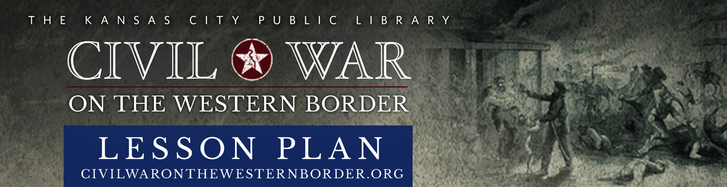

OVERVIEW |  | The Kansas-Nebraska Act and the Road to the Civil War
GRADE LEVEL:  8-12 |  | 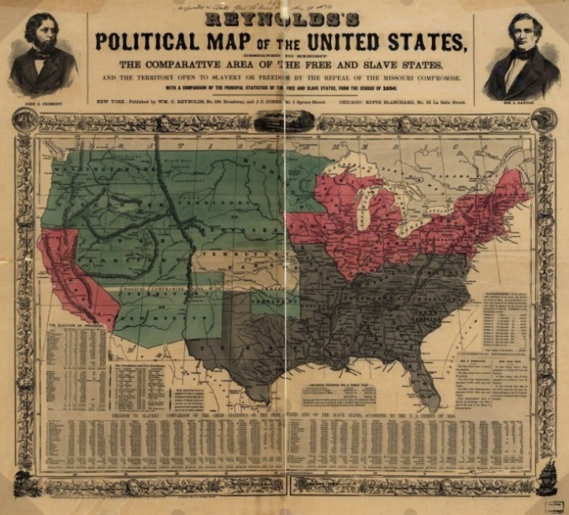  Created by Anthony Ruiz, California Trail Middle School, Olathe, Kansas  Introduction  During the antebellum period, the United States fell into political and social turmoil; the nation was divided over the issue of slavery. The representatives of Southern and Northern states sought to protect their interests by pursuing policies that would expand or prohibit slavery as new Western states joined the Union. The resulting series of compromises attempted to ensure stability by maintaining a balance of free and slave states. The Missouri Compromise of 1820, for instance, allowed Missouri to enter the Union as a slave state, but prohibited slavery in western territories north of the latitude line of 36°30′.  Reynold’s Political Map of the United States – The Complete Area of the Free and Slave States, ca. 1856. Library of Congress Georgraphy and Map Division, Washington, D. C.  In 1854, the debate over slavery reached new heights and resulted in a new compromise, the Kansas-Nebraska Act. Senator Stephen Douglas, from Illinois, proposed that slavery could extend into territories above the Missouri Compromise line of 36°30′. Douglas’s legislation organized the Kansas and Nebraska territories and included a provision for “popular sovereignty,” which allowed the elected representatives of the residents of those territories to decide whether to permit slavery. Douglas touted that this agreement would “triumph & impart peace to the country and stability to the Union.” For Douglas, popular sovereignty gave the people the power to democratically determine their states’ internal affairs.  Douglas maneuvered the Kansas-Nebraska Act through Congress. However, this legislation did not provide any stability. In reality, it further polarized the nation. Northerners were outraged that the 36°30′ line had been repealed and believed the “slave power” (referring to the political influence of Southern slaveholders) could now extend into free territories. Southerners saw an opportunity to extend slavery into the future state of Kansas, and both sides encouraged settlers to move to Kansas and vote to protect their interests. As a result, hostile ideological differences led to a civil war in Kansas, predating the national Civil War by several years. Proslavery Missourians, called “border ruffians,” and antislavery Kansans, called “jayhawkers,” engaged in violence, intimidation, and murder to control voting and political authority in Kansas; this gave rise to the region’s name, “Bleeding Kansas.” In the end, irregular voting patterns and electoral fraud halted attempts by Congress to recognize Kansas as a state until 1861, when the outbreak of the Civil War finally allowed Kansas to be admitted to the Union as a free state. Numerous historians have argued that the Kansas-Nebraska Act led to the Civil War and that the Civil War began with the violence on the Missouri-Kansas border.  Objectives  Using primary and secondary source documents, students will:  - Compare and contrast proslavery and antislavery sentiments relating to the Kansas-Nebraska Act.  - Summarize the economic and political concerns and fears that settlers in Kansas and residents of Missouri experienced due to the Kansas-Nebraska Act.  - Identify migration patterns of settlers into Kansas during the 1850s.  - Analyze events that sparked violence and actions taken toward securing peace in Kansas.  - List events and figures related to the events of the Bleeding Kansas period.  Requirements  Students will require access to web accessible computers or tablets.  Instructional Plan  - Instruct students to read Silas Reed’s letter written to Mrs. Abner Stone and respond to the following questions:  - Silas Reed writes that “Kansas & Nebraska turned out as I feared…” What predictions might he have made about Kansas and Nebraska?  - Why did Reed believe the environment of Kansas would influence the final outcome?  - What migration pattern was Reed counting on to avenge the “compromise”?  - Have students connect to the Border War Timeline. Provide them time to examine and research the green political and blue national events of 1854. When completed, instruct students to respond to the following questions:  - Which political party do you feel Reed would have joined and why?  - Using the date of Reed’s letter, what is the total number of months he could have been a member of that political party?  - Why was the Massachusetts Emigrant Aid Society founded?  - What was the first city founded by the Massachusetts Emigrant Aid Society?  - What was the first city in Kansas founded by Missourians?  - How many weeks had the Emigrant Aid Society been in Kansas when Reed wrote his letter?  - Instruct students to read J. Locke Hardeman’s letter to George R. Smith and respond to the following questions and prompts:  - According to J. Locke Hardeman, why were aid societies coming to Kansas?  - How does Hardeman describe the plight of Missourians living in Kansas?  - Why was Hardeman so concerned about the fate of Missouri?  - When writing of possible disunion, what types of wars does Hardeman predict might happen?  - Compare the statement from Hardeman’s letter, “Perhaps this once glorious union may survive the shock of Civil War! – This! God in his providence only knows – I know that abolition & union can not stand together,” with the ideas and beliefs expressed in the first 11 sentences of Abraham Lincoln’s “House Divided” speech.  - In his postscript, Hardeman communicates a more mollified tone. He indicates that he did “not expect a public war,” and while he did expect some violence, he also believed that the country as a whole would not breakout in civil war due to high costs to the nation. According to Hardeman, what were the political and economic reasons that the United States had to survive?  - Have students connect to the Border War Timeline. Provide them with time to examine and research the events of 1855. When completed, instruct students to list five events, their dates, and their significance that proslavery supporters such as Hardeman might have supported using the following table:  - Instruct students to read Governor John W. Geary’s proclamation, followed by the resulting petition from leaders of an emigrant train to Kansas in 1865 and respond to the following questions:  - Why did the conductors of the emigrant train call themselves “bona-fide settlers”?  - Which items were taken from the emigrant group?  - Why do you think U.S. Marshall Preston acted the way that he did?  - Which amendments did the emigrant group claim protect them from such actions?  - Do you agree with the conductors or with Preston?  - Have students connect to the Border War Timeline. Provide them with time to examine and research the red instances of violence in 1856. When completed, instruct students to respond to the following questions and prompts:  - Which event started the violence in 1856 and what happened?  - List the antislavery and proslavery violent events occurring in Kansas following the event from the previous question.  - How many violent events are associated with John Brown?  Standards Statement  This lesson plan has been designed in keeping with the National Council for the Social Studies’ framework for social studies content standards, with focus placed upon the goals of encouraging students to better understand important concepts, such as change over time, historical context, continuity, and bias, so that they may become more effective historical researchers and argumentative writers.  Suggested Assessment Rubric
  Proslavery Events of 1855
  Event | Date | Significance
  1.
  2.
  3.
  4.
  5.
  CATEGORY | 4 | 3 | 2 | 1
  Identifies important information | Student lists all the main points from the selected primary resources in response to questions and prompts. | Student lists all but a few of the main points from the selected primary resources in response to questions and prompts. | Student lists most of the main points from the selected primary resources in response to questions and prompts. | Student has not listed most of the main points from the selected primary resources in response to questions and prompts.
  Identifies opinions | Student demonstrates a clear ability to identify and explain different points of view and historical bias. | Student can identify and explain different points of view and historical bias, but misses a few opportunities to cite examples. | Student can identify and explain different points of view and historical bias and has cited a few examples. | Student has not identified or explained different points of view or historical bias.
  Identifies facts | Student has identified all of the important names, dates, and events in response to questions and prompts using the Border War Timeline. | Student has identified all but a few of the important names, dates, and events in response to questions and prompts using the Border War Timeline. | Student has identified most of the important names, dates, and events in response to questions and prompts using the Border War Timeline. | Student has not identified most of the important names, dates, and events in response to questions and prompts using the Border War Timeline.
  Summarization | Student has composed clear sentences citing multiple examples from primary resources in response to questions and prompts. | Student has composed clear sentences citing some examples from primary resources in response to questions and prompts. | Student has composed somewhat clear sentences citing a few examples from primary resources in response to questions and prompts. | Student has not composed clear sentences and has not cited many examples from primary resources in response to questions and prompts.
SUBJECT:

U.S. History

Missouri History

Kansas History

ESTIMATED
CLASS TIME:

90-120 Minutes

WEBSITE RESOURCES:

Letter from Silas Reed to Mrs. Abner Stone, August 16, 1854

Border War Timeline

Letter from J. Locke Hardeman to George R. Smith, June 10, 1855

Abraham Lincoln’s “House Divided” Speech

Proclamation of Kansas Governor John W. Geary

Petition from Leaders of Emigrant Train to Governor John W. Geary, October 14, 1856

Assessment rubrics created using Rubistar. http://rubistar.4teachers.org/

